**FITFLEX: YOUR PERSONAL FITNESS COMPANION**

**(FITNESS TRACKER)**

**Team Leader: RAJA LAKSHMI M**

**Team Members: RATHILA R, REETHU HERALD I, SANGEETHA K**

**Introduction:**

The rapid advancement of technology has significantly influenced various aspects of human life, including health and fitness. With increasing awareness about the importance of maintaining an active lifestyle, fitness trackers have gained popularity as essential tools for monitoring physical activities and overall well-being. These wearable devices, often equipped with sensors and smart algorithms, enable users to track their daily steps, calories burned, heart rate, and even sleep patterns. The emergence of fitness trackers is a testament to the growing demand for digital health solutions that provide users with actionable insights into their health metrics.

Fitness trackers are available in different forms, including wristbands, smartwatches, and clip-on devices. Popular brands such as Fitbit, Apple Watch, Garmin, and Xiaomi have dominated the market, offering features that cater to different user needs. While these devices are widely adopted by fitness enthusiasts and athletes, they are also being increasingly used for medical and health monitoring purposes.

**Description:**

A fitness tracker is a wearable device designed to monitor and track various fitness-related metrics such as steps taken, distance travelled, calories burned, heart rate, and sleep patterns. These devices utilize sensors and smart algorithms to provide real-time health data, encouraging users to maintain an active lifestyle. With advancements in technology, fitness trackers have evolved to include features like GPS tracking, hydration reminders, and integration with mobile applications for data analysis. This study aims to analyze the functionality, impact, and technological framework of fitness trackers, emphasizing their role in health monitoring, fitness motivation, and overall well-being.

**Project Overview:**

**Purpose:**

The fitness tracker project aims to help users monitor and improve their physical activity, health, and overall well-being. It collects real-time data related to fitness activities, such as steps taken, calories burned, heart rate, and sleep patterns, enabling users to set and achieve their fitness goals efficiently.

**Key Features:**

1. **Activity Tracking:**

* Tracks steps, distance travelled, and calories burned.
* Logs various exercises such as walking, running, cycling, and strength training.

1. **Heart Rate & Health Monitoring:**

* Monitors heart rate in real-time and provides insights.
* Tracks blood oxygen levels and stress levels.

1. **Sleep Tracking:**

* Records sleep duration and quality (deep sleep, light sleep, REM cycles).
* Provides recommendations for better sleep habits.

1. **Goal Setting & Progress Reports:**

* Allows users to set fitness goals (e.g., daily step count, weight loss, workout frequency).
* Generates weekly and monthly progress reports with insights.

1. **Calorie & Nutrition Tracking:**

* Logs food intake and calculates calories consumed.
* Provides dietary recommendations based on fitness goals.

1. **Connectivity & Syncing:**

* Syncs with smartphones via Bluetooth to store and analyze data.
* Integrates with other fitness apps (Google Fit, Apple Health, MyFitnessPal).

1. **Reminders & Notifications:**

* Sends reminders for workouts, hydration, and movement.
* Alerts users about prolonged inactivity.

1. **User Dashboard & App Interface:**

* Provides an interactive UI for viewing fitness stats and reports.
* Customizable widgets for quick access to key metrics.

1. **Social & Gamification Features:**

* Enables users to compete with friends and join fitness challenges.
* Provides achievements and rewards for completing goals.

1. **Wearable Device Compatibility:**

* Works with smartwatches, fitness bands, and mobile apps.
* Offers real-time tracking through wearable sensors.

**Scenario-Based Introduction:**

Imagine John, a corporate employee with a sedentary lifestyle, decides to improve his health. He purchases a fitness tracker to monitor his daily activity and ensure he meets his fitness goals. Initially, John sets a target of 10,000 steps per day, and the tracker provides him with real-time feedback on his progress. Over time, he starts monitoring his heart rate and sleep quality, gaining deeper insights into his overall health. The device's reminders and personalized recommendations keep him motivated, eventually leading to a significant improvement in his physical fitness. This scenario highlights the potential of fitness trackers in transforming lifestyles.

**Architecture Overview:**

A **fitness tracker** application requires a **scalable, modular, and real-time architecture** to handle user data, device integration, and analytics efficiently. Below is a high-level **architectural overview** that includes **component structure, state management, routing, and integrations**.

The fitness tracker follows a **3-tier architecture**:

**Frontend (User Interface Layer):**

* **Technologies:** React.js, Flutter, Swift, Kotlin (for mobile apps)
* **Responsibilities:**
  + Displays fitness stats (Steps, Calories, Heart Rate, Sleep, etc.).
  + Syncs data from wearable devices via Bluetooth/Web APIs.
  + Provides notifications, reminders, and goal tracking.
  + Offers social features like challenges and leaderboard.
  + Manages authentication (OAuth, JWT, Firebase).

**Backend (Application Layer):**

* **Technologies:** Node.js (Express.js), Django, FastAPI
* **Responsibilities:**
  + Handles API requests for user activity, health data, and progress reports.
  + Processes real-time data from wearables.
  + Provides insights and recommendations using AI/ML models.
  + Sends notifications & reminders (via Firebase Cloud Messaging, Twilio).

**Database (Data Storage Layer)**

* **Technologies:** PostgreSQL, MongoDB, Firebase Realtime DB, Redis
* **Responsibilities:**
  + Stores user profiles, workout history, sleep data, etc.
  + Logs real-time sensor data (heart rate, steps, calories).
  + Uses Redis for caching frequently accessed data.

**Technical Architecture:**

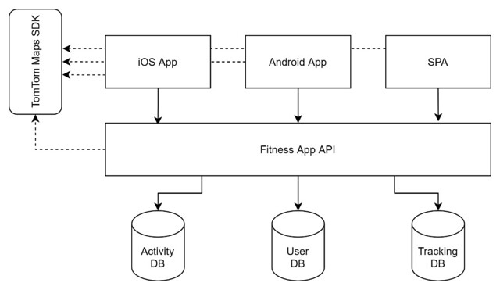

The technical architecture of a fitness tracker typically consists of the following components:

1. **Sensors Layer** – Includes accelerometers, gyroscopes, heart rate sensors, and temperature sensors to collect raw health data.
2. **Processing Unit** – A microcontroller unit (MCU) processes the sensor data and executes algorithms for real-time analysis.
3. **Connectivity Module** – Utilizes Bluetooth, Wi-Fi, or NFC for data synchronization with smartphones and cloud platforms.
4. **Storage and Memory** – On-board memory stores activity logs before syncing with cloud storage.
5. **Display and User Interface** – Touchscreen or LED display provides real-time updates and interaction features.
6. **Cloud Integration** – Stores user data on secure cloud servers for historical analysis and AI-based insights.

**PRE-REQUISITES:**

Here are the key prerequisites for developing a frontend application using React.js:

**✔Node.js and npm:**

Node.js is a powerful JavaScript runtime environment that allows you to run JavaScript code on the local environment. It provides a scalable and efficient platform for building network applications. Install Node.js and npm on your development machine, as they are required to run JavaScript on the server-side.

● Download: <https://nodejs.org/en/download/>

● Installation instructions: <https://nodejs.org/en/download/package-manager/>

**✔ React.js:**

React.js is a popular JavaScript library for building user interfaces. It enables developers to create interactive and reusable UI components, making it easier to build dynamic and responsive web applications. Install React.js, a JavaScript library for building user interfaces.

● Create a new React app:

npx create-react-app my-react-app

Replace my-react-app with your preferred project name.

● Navigate to the project directory:

cd my-react-app

● Running the React App:

With the React app created, you can now start the development server and see your React application in action.

● Start the development server:

npm start this command launches the development server, and you can access your React app at http://localhost:3000 in your web browser.

✔**HTML, CSS, and JavaScript**: Basic knowledge of HTML for creating the structure of your app, CSS for styling, and JavaScript for client-side interactivity is essential.

✔ **Version Control**: Use Git for version control, enabling collaboration and tracking changes throughout the development process. Platforms like GitHub or Bitbucket can host your repository.

• Git: Download and installation instructions can be found at: https://git-scm.com/downloads

**✔ Development Environment:**

Choose a code editor or Integrated Development Environment (IDE) that suits your preferences, such as Visual Studio Code, Sublime Text, or WebStorm.

• Visual Studio Code: Download from <https://code.visualstudio.com/download>

• Sublime Text: Download from <https://www.sublimetext.com/download>

**To get the Application project from drive:**

**Follow below steps:**

**✔ Get the code:**

• Download the code from [**https://drive.google.com/drive/folders/1f5Nv5oV92a1RkdLMgAKwNni-03CDPyBJ**](https://drive.google.com/drive/folders/1f5Nv5oV92a1RkdLMgAKwNni-03CDPyBJ)

**Install Dependencies:**

the drive link given below:

• Navigate into the cloned repository directory and install libraries:

cd fitness-app-react

npm install

✔ **Start the Development Server**:

• To start the development server, execute the following command:

npm start

**Project structure:**

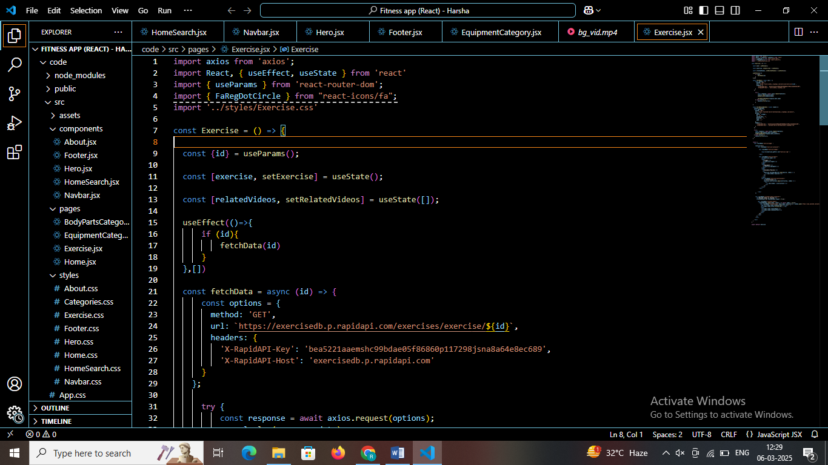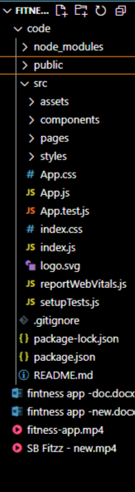

**Project Flow:**

**Project demo:**

Before starting to work on this project, let’s see the demo.

Demo link:

[**https://drive.google.com/file/d/187jePyPlP2sqgoYIxdLbSZLrlOcAO9W4/view?usp=sharing**](https://drive.google.com/file/d/187jePyPlP2sqgoYIxdLbSZLrlOcAO9W4/view?usp=sharing)

Use the code in:

<https://drive.google.com/drive/folders/1f5Nv5oV92a1RkdLMgAKwNni-03CDPyBJ>

**Milestone 1: Project setup and configuration.**

**Installation of required tools**:

To build the FitFlex app, we'll need a developer's toolkit. We'll leverage React.js for the interactive interface, React Router Dom for seamless navigation, and Axios to fetch fitness data. To style the app, we'll choose either Bootstrap or Tailwind CSS for pre-built components and a sleek look.

Open the project folder to install necessary tools. In this project, we use:

o React Js

o React Router Dom

o React Icons

o Bootstrap/tailwind css

o Axios

**Milestone 2: Project Development**

❖ Setup the Routing paths

Setup the clear routing paths to access various files in the application.

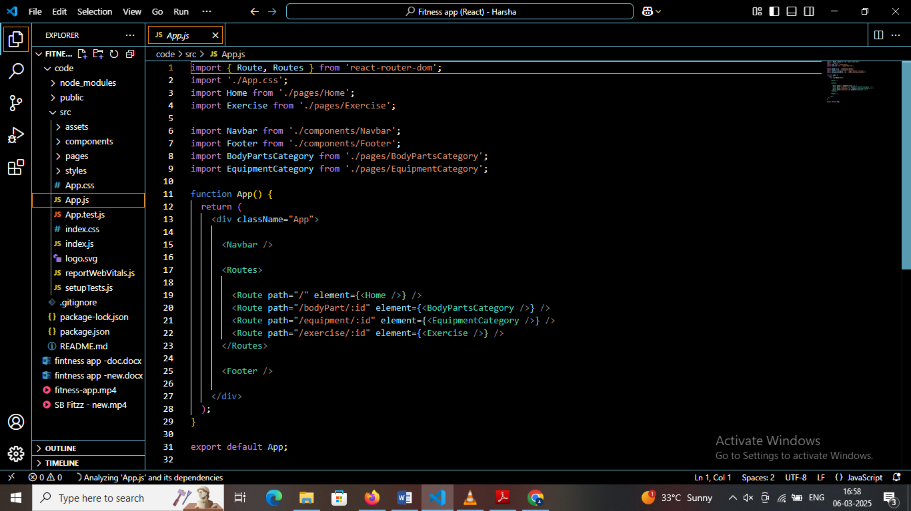

* Develop the Navbar and Hero components

❖ Code the popular search/categories components and fetch the categories from ***rapid Api***.

❖ Additionally, we can add the component to subscribe for the newsletter and the footer.

❖ Now, develop the category page to display various exercises under the category.

❖ Finally, code the exercise page, where the instructions, other details along with related videos from the YouTube will be displayed.

**Important Code snips:**

**􀀀 Fetching available Equipment list & Body parts list**

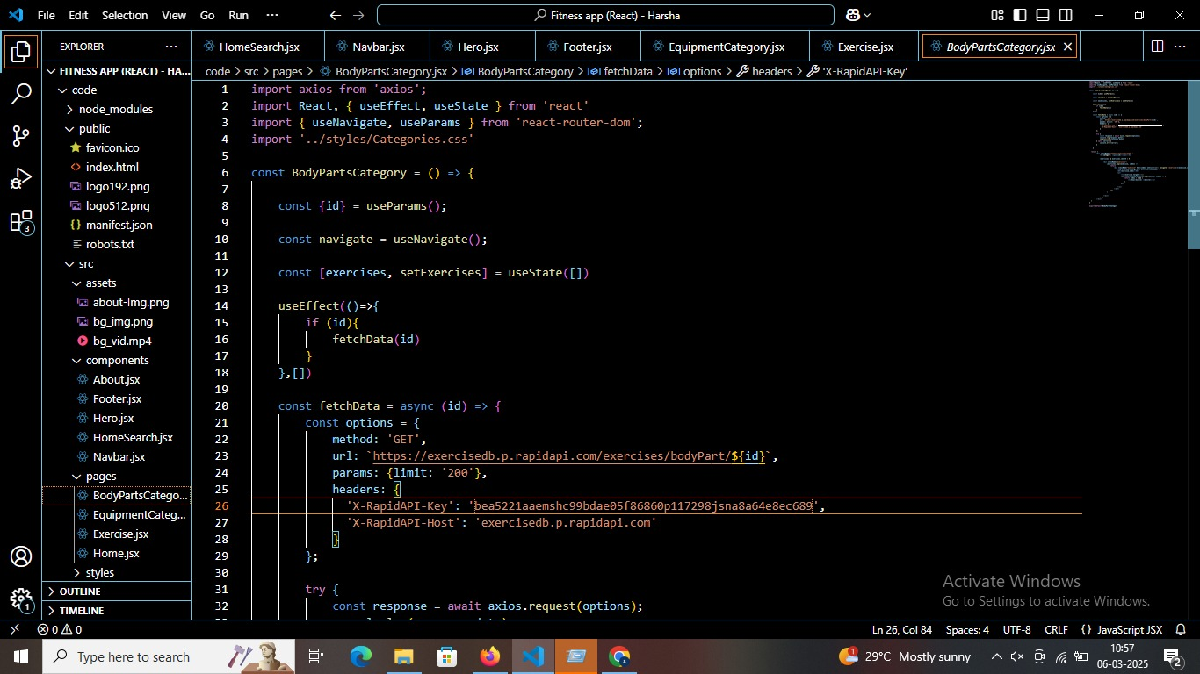

From the Rapid API hub, we fetch available equipment and list of body parts with an API request.

**Dependencies:**

The code utilizes the following libraries:

**Axios:**

A popular promise-based HTTP client for JavaScript. You can add a link to the official documentation for Axios https://axios-http.com/

**API Key:**

Replace 'place your api key' with a placeholder mentioning that the user needs to replace it with their own RapidAPI key. You can mention how to acquire an API key from RapidAPI.

**bodyPartsOptions and equipmentOptions:**

These variables hold configuration options for fetching data from the RapidAPI exercise database.

● method*:* The HTTP method used in the request. In this case, it's set to GET as the code is fetching data from the API.

● url*:* The URL of the API endpoint to fetch data from. Here, it's set to https://exercisedb.p.rapidapi.com/exercises/bodyPartList for fetching a list of body parts and https://exercisedb.p.rapidapi.com/exercises/equipmentList for fetching a list of equipment.

● headers*:* This section contains headers required for making the API request. Here it includes the X-RapidAPI-Key header to provide your API key and the X-RapidAPI-Host header specifying the host of the API.

**􀀀 Fetching exercises under particular category**

To fetch the exercises under a particular category, we use the below code.



It defines a function called fetchData that fetches data from an exercise database API. Here's a breakdown of the code:

***const options = {...}:***

This line creates a constant variable named options and assigns it an object literal. The object literal contains properties that configure the API request, including:

● method: Set to 'GET', indicating that the API request is a GET request to retrieve data from the server.

● url: Set to https://exercisedb.p.rapidapi.com/exercises/equipment/${id}, which is the URL of the API endpoint for fetching exercise equipment data. The ${id} placeholder will likely be replaced with a specific equipment ID when the function is called.

● params: An object literal with a property limit: '50'. This specifies that you want to retrieve a maximum of 50 exercise equipment results.

● headers: An object literal containing two headers required for making the API request:

● 'X-RapidAPI-Key': Your RapidAPI key, which is used for authentication. You should replace 'your api key' with a placeholder instructing users to replace it with their own API key.

● 'X-RapidAPI-Host': The host of the API, which is 'exercisedb.p.rapidapi.com' in this case.

*const fetchData = async (id) => {...}:*

This line defines an asynchronous function named fetchData that takes an id parameter. This id parameter is likely used to specify the equipment ID for which data needs to be fetched from the API.

**􀀀 Fetching Exercise details**

Now, with the help of the Exercise ID, we fetch the details of a particular exercise with API request

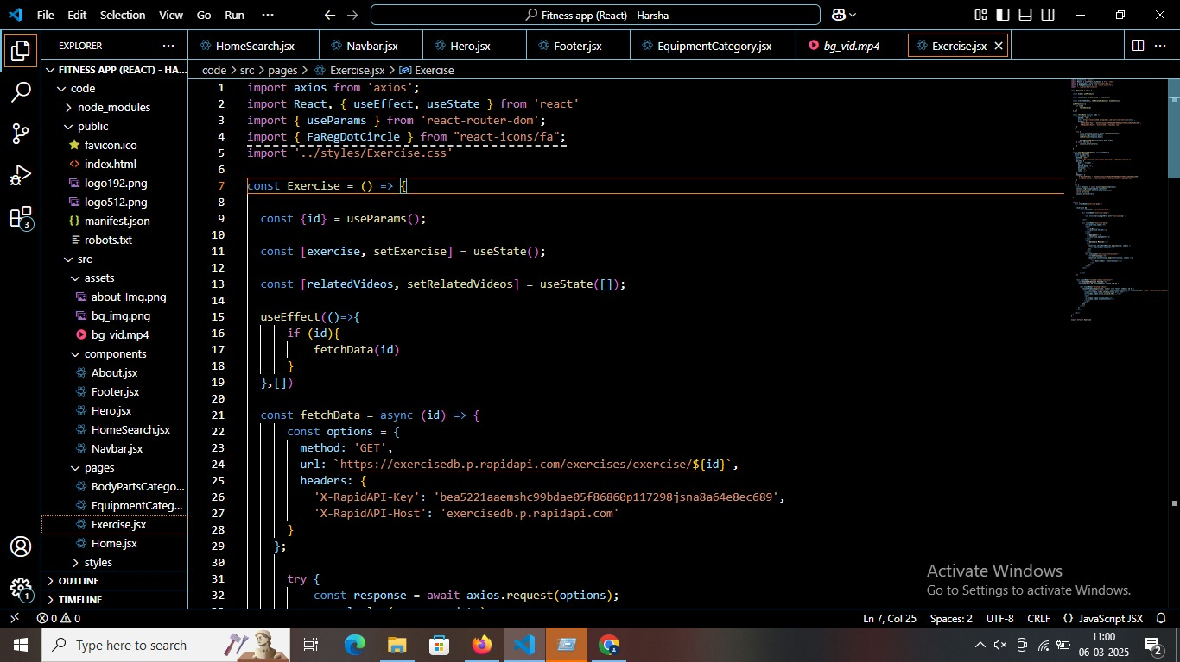

The code snippet demonstrates how to fetch exercise data from an exercise database API using JavaScript's fetch API. Here's a breakdown of the code:

**API Endpoint and Key:**

● Replace 'https://example.com/exercise' with the actual URL of the API endpoint you want to use.

● Replace 'YOUR_API_KEY' with a placeholder instructing users to replace it with their own API key obtained from the API provider.

**async function:**

The code defines an asynchronous function named fetchData that likely takes an id parameter as input. This id parameter might be used to specify the ID of a particular exercise or category of exercises to fetch.

**fetch request:**

Inside the fetchData function, the fetch API is used to make an HTTP GET request to the API endpoint. The function creates a fetch request with the following details:

● Method: GET (to retrieve data from the server)

● URL: The API endpoint URL where exercise data resides.

**Handling the Response:**

● The then method is used to handle the response from the API request. If the request is successful (i.e., status code is 200), the response is converted to JSON format using response.json().

● The .then method then likely processes the fetched exercise data, which might involve storing it in a state variable or using it to populate a user interface.

**Error Handling:**

The .catch method is used to handle any errors that might occur during the API request. If there's an error, it's logged to the console using console.error.

**Project Execution:**

After completing the code, run the react application by using the command “npm start” or “npm run dev” if you are using vite.js

Here are some of the screenshots of the application.

* **Hero component**

this section would showcase trending workouts or fitness challenges to grab users' attention.

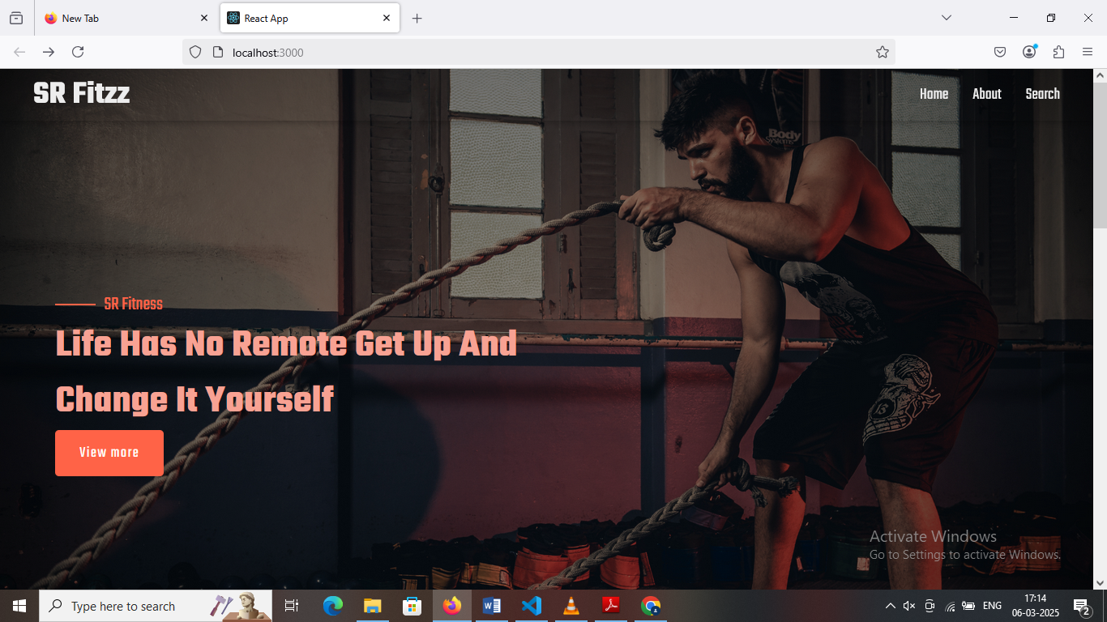

* **About**

FitFlex isn't just another fitness app. We're meticulously designed to transform your workout experience, no matter your fitness background or goal

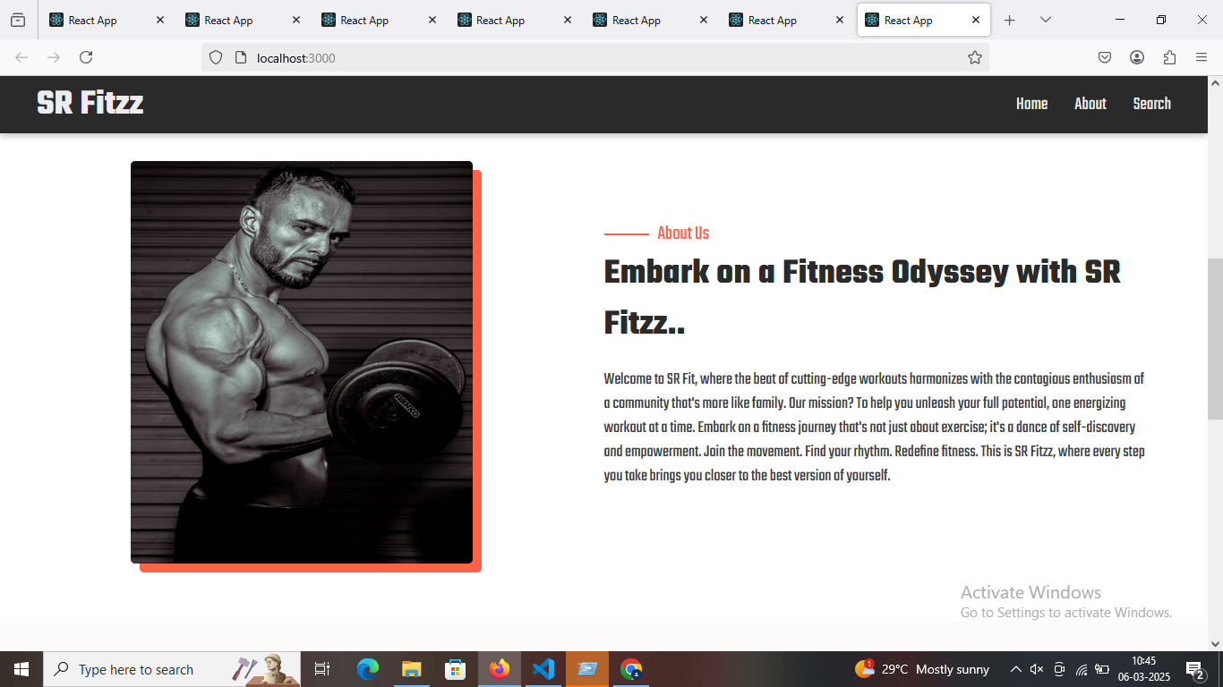

* **Search**

SR Fitzz makes finding your perfect workout effortless. Our prominent search bar empowers you to explore exercises by keyword, targeted muscle group, fitness level, equipment needs, or any other relevant criteria you have in mind. Simply type in your search term and let FitFlex guide you to the ideal workout for your goals.

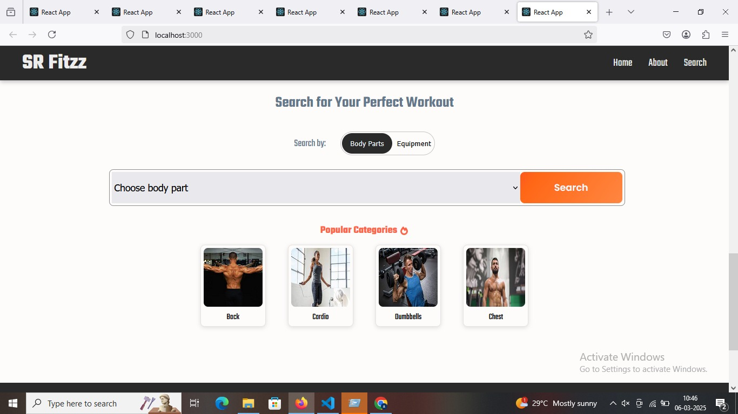

* **Category page**

FitFlex would offer a dedicated section for browsing various workout categories. This could be a grid layout with tiles showcasing different exercise types (e.g., cardio, strength training, yoga) with icons or short descriptions for easy identification.

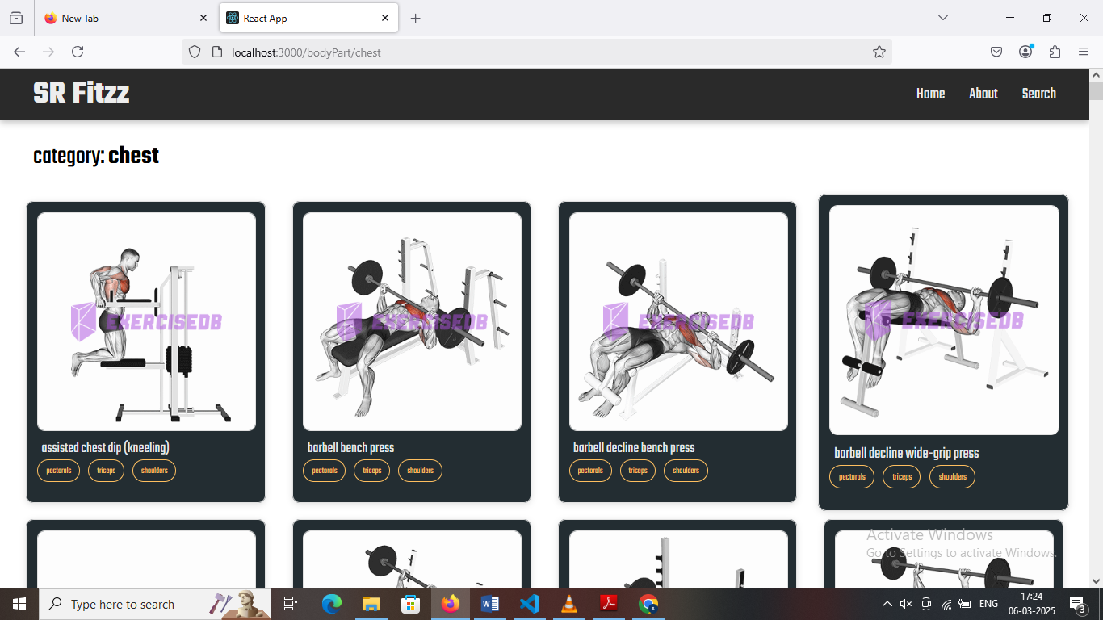

* **Exercise page**

This is where the magic happens! Each exercise page on FitFlex provides a comprehensive overview of the chosen workout. Expect clear and concise instructions, accompanied by high-quality visuals like photos or videos demonstrating proper form. Additional details like targeted muscle groups, difficulty level, and equipment requirements (if any) will ensure you have all the information needed for a safe and effective workout.

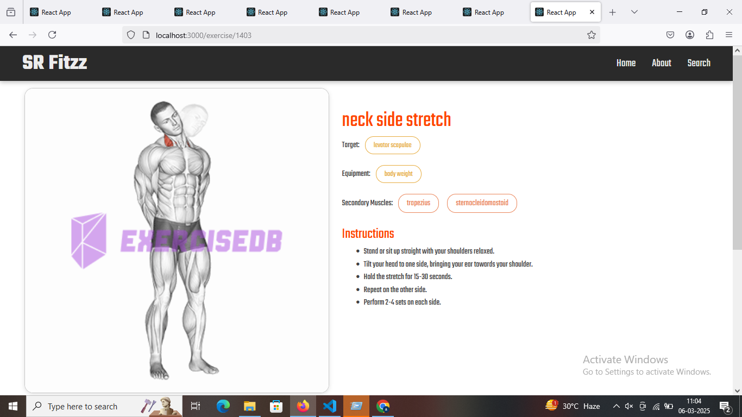

### ****Future Enhancements:****

As technology evolves, several **enhancements** can be integrated into a fitness tracker to improve functionality, user engagement, and accuracy. Here are some **potential future upgrades**:

## ****1. AI & Machine Learning Enhancements****

✅ **Personalized Workout & Diet Plans** – AI can analyze user data and recommend tailored workout routines and meal plans.  
✅ **Health Anomaly Detection** – Machine learning can detect irregularities in heart rate or sleep patterns and alert users.  
✅ **Smart Voice Assistant Integration** – Users can ask Alexa, Google Assistant, or Siri for fitness stats and guidance.

## ****2. Advanced Wearable & IoT Integrations ⌚****

✅ **ECG & Blood Pressure Monitoring** – Adding more advanced health tracking metrics.  
✅ **Smart Clothing Integration** – Wearable smart fabrics that measure muscle movement and posture.  
✅ **Hydration & Nutrition Sensors** – Devices that track hydration levels or suggest diet changes based on real-time data.

## ****3. Social & Gamification Features 🏆****

✅ **Live Fitness Challenges** – Users can participate in global or friend-based fitness competitions.  
✅ **Virtual Personal Trainer** – AI-powered coaching via augmented reality (AR).  
✅ **Reward System** – Earn points, badges, or discounts for achieving fitness goals.

## ****4. Real-Time Health Monitoring & Emergency Alerts 🚨****

✅ **Fall Detection & Emergency SOS** – Alerts emergency contacts in case of a fall or irregular heart rate.  
✅ **Remote Health Monitoring** – Allow doctors or trainers to monitor user health remotely.  
✅ **Stress & Mental Health Analysis** – AI-driven insights into stress levels with meditation recommendations.

## ****5. Blockchain for Data Security & Ownership 🔐****

✅ **Decentralized Health Data Storage** – Users fully control their fitness data.  
✅ **Secure Data Sharing** – Users can share fitness data with doctors securely using blockchain.  
✅ **NFT-based Achievements** – Fitness milestones as unique NFTs or digital collectibles.

## ****6. Cross-Platform & Smart Device Compatibility 📱****

✅ **Integration with Smart Home Devices** – Sync with smart mirrors, treadmills, and VR fitness systems.  
✅ **Fitness Tracker for Pets** – Monitor pet activity, calories, and health.  
✅ **Metaverse & Virtual Workouts** – Participate in virtual reality (VR) fitness training sessions.

### ****Final Thoughts 🚀****

With these enhancements, the fitness tracker can evolve into a **personalized digital health assistant** rather than just a step counter.

**Demo link**: [**https://drive.google.com/file/d/187jePyPlP2sqgoYIxdLbSZLrlOcAO9W4/view?usp=sharing**](https://drive.google.com/file/d/187jePyPlP2sqgoYIxdLbSZLrlOcAO9W4/view?usp=sharing)

**…..HAPPY CODING…..**